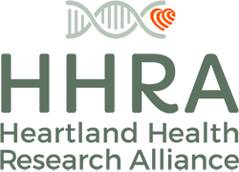

Strategic Plan: 2022 – 2025

Approved by HHRA Board of Directors on November 10, 2022

Contents
Part 1: Who We Are 2
Why We’re Here 2
Our Story: Farming in the Heartland 2
Our Story: Health in the Heartland 3
Our Vision and Mission: Science, Food, and Farming for Health 4
Our Unique Value 4
Part 2: What We Do 5
Strategy Overview 5
The Structure of Our Strategy 6
HHRA’s Strategy: 2022-2025 in Summary 7
HHRA’s StrategyThrough 2025 8
Part 3: Fundraising, Implementation, and Monitoring 14
Our Approach to Fundraising 14
Monitoring and Evaluation Guidelines 17
Final Note 18

Part 1: Who We Are

Why We’re Here

The Heartland Health Research Alliance (HHRA) was established by agriculture and medical scientists to conduct research at the intersection of farming systems, food safety, environmental quality, and public health. We support scientists who are answering vital questions about how farming practices affect the health of people and the environment.

It’s an urgent calling. Today, agriculture is a massive, global industry that utilizes most of the arable land on the planet and over one-half of freshwater resources. In many agricultural regions, intensive farming practices have required increasingly heavy use off-farm inputs, including chemical fertilizers and pesticides. The public health effects of rising reliance on herbicides among farmers and their families and employees, people living in rural areas alongside intensive agriculture, or society as a whole are not well understood.

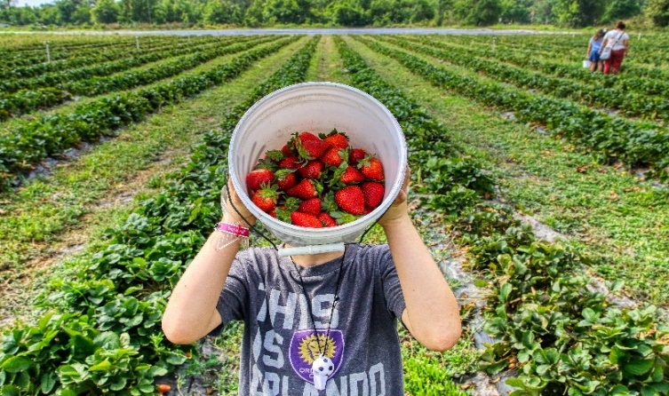
Against this background, HHRA supports research that strengthens the connections between food, farming, and public health. We fill knowledge gaps, build research infrastructure, and bridge scientific disciplines to help everyone understand more fully the effects of farming practices on people’s health and the environment.
We believe in farming for food and health.

We do this work with a clear purpose: to equip farmers and leaders in business and government with the solid data needed to make informed, science-based decisions about agricultural practices.

As we implement this strategic plan from 2022 to 2025, HHRA will focus on the public health effects of herbicides, the most widely and heavily applied type of pesticide.

Our Story: Farming in the Heartland

HHRA’s story begins on the farms of the Heartland.

More than 150 million acres of corn and soybeans are grown annually in the US, mostly in the Midwest. These crops are the backbone of the US food supply.

Growing them requires farmers to control weeds that compete with crops for often-limited water and nutrients in the soil. Given the narrow margins that determine whether farms succeed or fail, farmers require cost-effective tools to manage weeds.

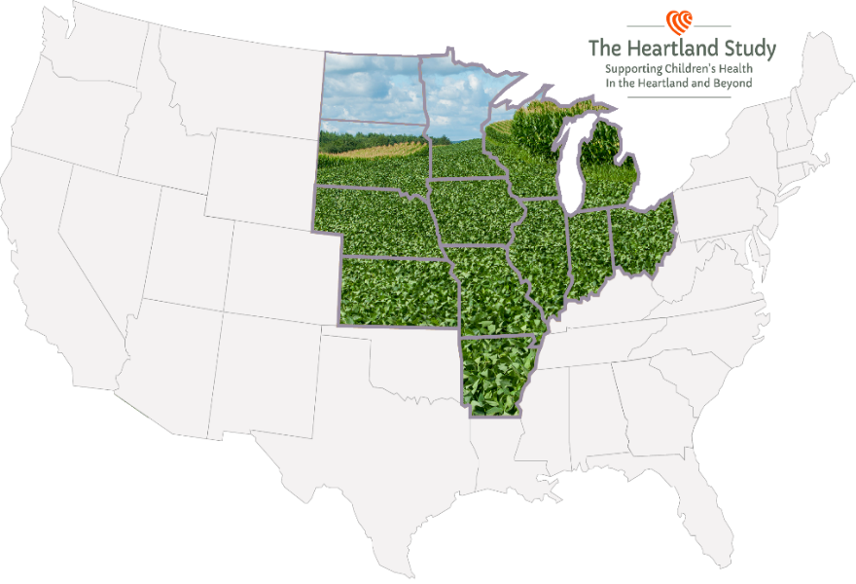
One new tool was introduced in 1996 – cotton and soybeans were genetically engineered to survive application of a herbicide called glyphosate (aka Roundup) that kills essentially all green and growing plants. Other “Roundup Ready” crops soon came on the market. Such herbicide-tolerant seeds and crops quickly took over the market, and glyphosate became the go-to tool for weed control.
HHRA defines the 13-state Heartland region as the Midwestern states per the US Census plus Arkansas, an important soybean growing state.
vzc

Today, these genetically-engineered crops constitute over ninety percent of the corn and soybeans grown in the Heartland. During the two decades after the introduction of herbicide-tolerant crops, the number of herbicide treatments per acre of corn or soybeans in the Heartland increased by an average of 76%. Widespread adoption of this farming technology has lengthened the herbicide spray season in most areas from several weeks to three or four months, and studies have documented a corresponding increase in herbicide exposure rates in humans. Biomonitoring data compiled by HHRA also confirms that herbicide exposures are becoming more frequent and widespread throughout the Heartland.

This is why HHRA is determined to conduct careful clinical research to better understand the impacts of rising herbicide use and exposures in the Midwest and on the health of the 70+ million people who call it home.

Our Story: Health in the Heartland

Several of HHRA’s founders and scientific leaders come from the Heartland.

Living and working in farm country, they noticed increasing numbers of families struggling to conceive, carry pregnancies to term, and raise healthy children. Doctors expressed concern at the number of premature and sick babies in their neonatal intensive care units. Families with sick newborns and difficult pregnancies naturally asked their doctors “Why?”

The clinicians and scientists who founded and joined HHRA have wondered for some time whether there is a connection between rising use of herbicides and the reproductive health problems that were touching their friends, family, and co-workers across the Heartland. And so, a group of scientists and doctors came together to design a rigorous clinical study to answer the question many people in the Heartland were beginning to ask: Is rising herbicide exposure associated with reproductive problems, adverse birth outcomes, or developmental delays in America’s Heartland?

This question led to the launch HHRA’s flagship project: The Heartland Study – an observational research project exploring possible connections between reproductive health and herbicide exposure in the Midwest.

Phase 1 of The Heartland Study focuses on preterm birth and related complications, low birthweight, and birth defects. It is currently underway and enrolling pregnant women at our partners’ health care centers in the Heartland. Phase 2 will track the development of children through adolescence in order to determine whether herbicide exposure during pregnancy is linked to developmental challenges, as some recent studies suggest.

HHRA was founded in August of 2020 to provide (1) fiscal and operational support to scientific teams like the one conducting The Heartland Study, and (2) communications and public policy expertise to ensure that HHRA’s findings equip farmers, leaders in adjacent industries, and policy makers to make decisions based on sound science.

Our Vision and Mission: Science, Food, and Farming for Health

The Heartland Health Research Alliance was founded with a clear vision and mission in mind:

We envision a new future: one rooted in flourishing farms where agriculture is managed, first and foremost, to cultivate health.

Our mission is to inform the decisions that shape agriculture by advancing research on the health effects of food and farming.

During the next three years we will advance our mission by:

- Supporting research to determine whether widely-used weed-killing herbicides affect reproductive and children’s health.
- Sharing data and scientifically sound findings to equip farmers, the food industry, and policy makers to adopt farming-system practices that promote the health of people and the planet.

Our Unique Value

HHRA builds scientific infrastructure and improves analytical methods. We draw on a global network of scientific expertise, convening multidisciplinary teams of scientists to study how agricultural pesticides affect health.
HHRA’s science is led by scientists, unlike much of mainstream food and agricultural science which is often driven by industry priorities and corporate interests. HHRA provides essential resources to researchers willing to answer controversial questions despite the tensions that often accompany such research. We manage the fiscal and other back-end administrative tasks so researchers can focus on science. Our Alliance of doctors, researchers, policy experts and communicators works to answer questions that the government and private sector are too often unable or unwilling to address. By honing and improving analytical methods and research techniques and sharing them widely, we hope to make this work easier and more affordable for the entire research community. Most importantly, we strictly abide by all scientific and ethical best practices to keep our research above reproach.

HHRA fills data gaps. Much remains unknown about how rising pesticide exposure is affecting people and the environment. Our Alliance partners are hard at work filling critical data gaps and leveraging existing research. We develop and maintain tools and datasets that make it possible to connect the dots in new and more efficient ways.
One way HHRA is filling data gaps is by analyzing pesticide levels in stored biospecimens from previous studies, like the nuMoM2b (New Mom to Be) study on first-time moms in Indiana. Thus, we are leveraging today’s laboratory capacity to gather more accurate data from yesterday’s exposures.

HHRA builds research capacity. The intersection of agriculture and public health is vital but too often ignored. To create a much-needed pipeline of future research leaders, we partner with top-flight research institutions to establish career-defining academic fellowships for emerging scientists in agriculture and public health.

HHRA engages rural communities in research. Because most clinical research takes place at large hospitals in urban centers, the unique health concerns and constraints of rural communities are routinely omitted from ag-centric public-health science. This must change. At least one third of Heartland Study participants will be from rural areas and health care centers in mid-size and small cities will participate as full partners in our clinical research.

Part 2: What We Do

Strategy Overview

We envision a new future: one rooted in flourishing farms where agriculture is managed, first and foremost, to cultivate health.

This is the vision that unites Heartland Health Research Alliance’s (HHRA’s) team of nationally renowned medical, science, agriculture, economic, and public policy experts. At their urging, HHRA has chosen to focus its work through 2025 on two long-term outcomes: (1) collecting and generating reliable data, and integrating it with existing knowledge on the health effects of pesticides, and (2) ensuring those data and findings inform the decisions that shape our agriculture systems and food future.

The science comes first. In this sphere of our work, HHRA will document trends of human exposure to high-use herbicides (e.g., glyphosate, dicamba, glufosinate, and 2,4-D). We will determine whether rising herbicide use affects mother’s and/or children’s health, and we will make specific improvements in capacity to conduct research of this kind.
Our strategic priorities in this sphere are:

- Building the infrastructure to ensure HHRA’s data and findings remain above reproach and are widely accessible;
- Enrolling mother-infant pairs in Phase 1 of The Heartland Study, and planning for and beginning Phase 2 (tracking children’s development through age 16);
- Developing, improving, and sharing enhanced scientific tools to quantify exposures and explore links with adverse health outcomes;
- Quantifying long-term, historic trends in people’s herbicide exposure levels; and
- Building scientific knowledge and capacity on the intersection of public health and agriculture.

On a parallel track, HHRA will make sure that sound science informs the far-reaching public policy decisions that shape our agriculture system. Our strategic priorities in this sphere are:

- Planning and building our Alliance and our capacity so that we can influence government and private-sector decisions about agriculture’s effects on public health; and
- Making sure policy makers understand what science says about how our agriculture system affects the health of people and the planet.

The Structure of Our Strategy

The graphic below displays the elements of our strategy and the relationship between those elements.

This is how we define the elements of our strategy:

- Vision is the difference HHRA is working to make in the world; it is the ultimate aspiration driving our work.
- Mission is our business; it is the day-to-day work we do.
- Outcomes are the changes in the world that our programs will make or contribute to as we pursue our mission.
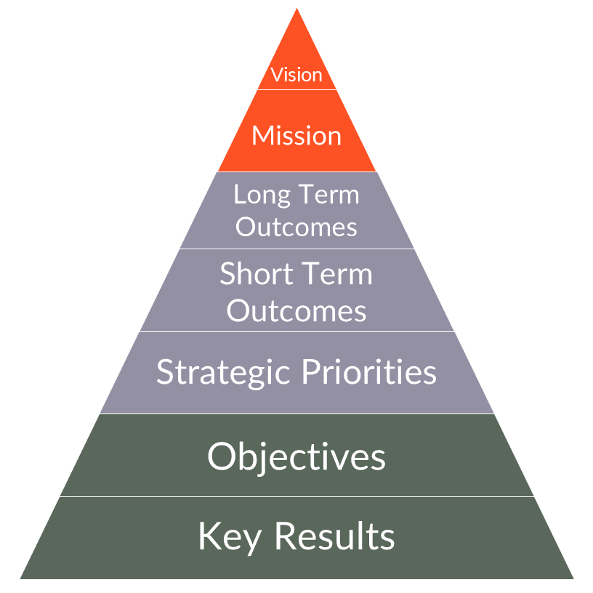
  - Long-term outcomes are the distant changes that we expect to happen on a time frame of ten years or more.
  - Short-term outcomes are the more proximate changes that we’ll pursue during this strategic plan.
- Strategic priorities are the goals that we aim to achieve in pursuit of our outcomes.
- Objectives are the major steps we will take to achieve our strategic priorities.
- Key results are the concrete targets and measures of achievement by which we will track our progress towards our objectives.

HHRA’s Strategy: 2022-2025 in Summary

The graphics below are an overview of HHRA’s strategy. See the following pages for a more detailed description including objectives and key results for each strategic priority.

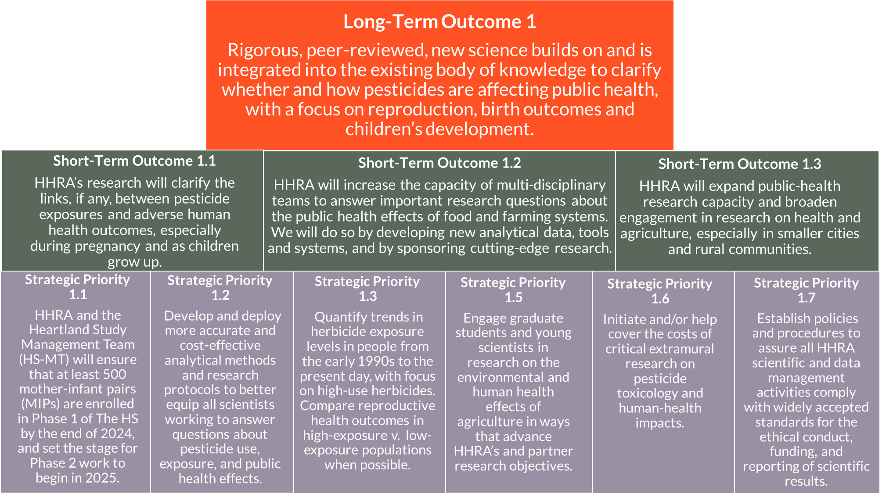

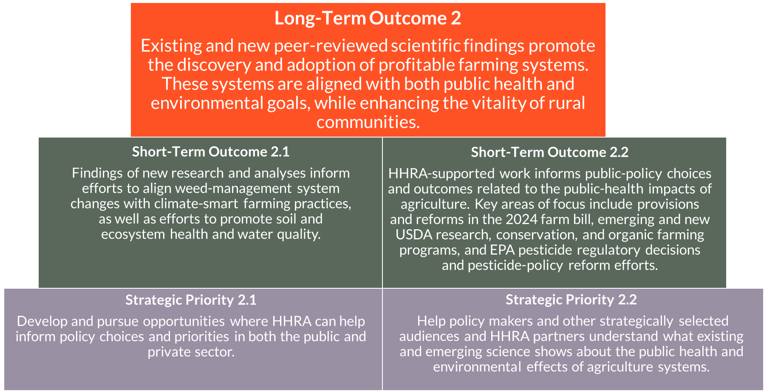

HHRA’s Strategy Through 2025

This section describes HHRA’s long- and short-term outcomes, the strategic priorities we will pursue through the end of 2025, and the objectives and key results that will define our work as we implement this plan.

Long-Term Outcome 1: Rigorous, peer-reviewed, new science builds on and is integrated into the existing body of knowledge to clarify whether and how pesticides are affecting public health, with a focus on reproduction, birth outcomes, and children’s development.

- Short-Term Outcome 1.1: HHRA’s research will clarify the links, if any, between pesticide exposures and adverse human health outcomes, especially during pregnancy and as children grow up.

- Short-Term Outcome 1.2: HHRA will increase the capacity of multi-disciplinary teams to answer important research questions about the public health effects of food and farming systems.

- Short-Term Outcome 1.3: HHRA will expand public health research capacity and broaden engagement in research on health and agriculture, especially in smaller cities and rural communities.

Strategic Priorities Serving Long-Term Outcome 1

Note: Strategic priorities may serve more than one STO (Short-Term Outcome).

- Strategic Priority 1.1: HHRA and the Heartland Study Management Team (MT) will ensure that at least 500 mother-infant pairs (MIPs) are enrolled in Phase 1 of The HS by the end of 2024, and set the stage for Phase 2 work to begin in 2025 (children’s development from age 3 through age 16).
  - Objective 1.1.1: Complete Phase 1 recruitment of 500 MIPs.
    - Key Result 1.1.1a: The process for selecting and recruiting new sites is finalized by 1/1/2023.
    - Key Result 1.1.1b: The roles of HHRA and the MT in recruitment of new sites are clarified and necessary recruitment materials are developed and vetted.
    - Key Result 1.1.1c: The HS-MT develops and periodically reassesses its Rural Recruitment Strategy to determine how the HS will meet rural recruitment goals.
    - Key Result 1.1.1d: 1-3 new study sites are enrolling MIPs by 2025, and collectively are recruiting 30% of new MIPs from outside urban centers.
  - Objective 1.1.2: Newly enrolled MIPs successfully move through the HS Phase 1 protocol at all study sites.
    - Key Result 1.1.2a: Majority of MIP and paternal participants are completing most study milestones, as documented by capitation reports.
    - Key Result 1.1.2b: HS study sites collect and transfer to long-term storage or analytical labs ~2,000 urine and ~2,800 buccal swab biospecimen samples by the end of 2024.
  - Objective 1.1.3: Data collection, management and analyses are effectively carried out and support cost-effective attainment of HS and HHRA goals.
    - Key Result 1.1.3a: Clarify and meet all HS data management needs (staffing, infrastructure, HIPPA compliance, etc) as the HS scales up.
    - Key Result 1.1.3b: HS analytical team is adequately staffed, meeting regularly, and able to perform key analysis and data management tasks.
    - Key Result 1.1.3c: HS procedures assure efficient management of biospecimen collection, coding, storage, and transport to analytical labs and/or research partners.
  - Objective 1.1.4: The operational plan is in place for the HS’s Phase 2 developmental assessments through age 16 by the end of 2023.
    - Key Result 1.1.4a: One or more Phase 2 PIs are identified.
    - Key Result 1.1.4b: Phase 2 hypotheses are drafted, vetted, and agreed upon, as well as the specific tests that will be carried out, by whom, and at what estimated cost.
    - Key Result 1.1.4c: Phase 2 budget projections are completed by month and year through ~2041.
    - Key Result 1.1.4d: HS Phase 2 hypotheses and protocols are approved by the MT, and the plan for covering the expenses entailed in Phase 2 is approved and operationalized.

- Strategic Priority 1.2: Develop and deploy more accurate and cost-effective analytical methods and research protocols to better equip all scientists working to answer questions about pesticide use, exposure, and public health effects.
  - Objective 1.2.1: Further develop and expand analytical systems to track pesticide use and dietary exposure.
    - Key Result 1.2.1a: The Pesticide Use Data System (PUDS) and the Dietary Risk Index (DRI) are moved to HHRA's website and are made accessible to all audiences.
    - Key Result 1.2.1b: Efforts are made to encourage use of the PUDS and DRI systems by researchers in need of such data and analytical capacity.
    - Key Result 1.2.1c: Mechanisms are developed to guide when and with whom HHRA will collaborate with outside scientists in developing and applying the PUDS, DRI and other HHRA analytical systems.
    - Key Result 1.2.1d: PUDS and the DRI analytical systems support epidemiological research, risk assessment, and work to make farming systems safer and more sustainable and track progress toward such goals.
  - Objective 1.2.2: Analyze HS buccal samples for biomarkers of epigenetic change possibly associated with heightened risk of adverse developmental and/or adult-onset health outcomes.
    - Key Result 1.2.2a: PI/research leaders for HS epigenetic analyses are identified by 1/1/2024 and guide work required to identify markers of pesticide-exposure induced epigenetic impacts.
    - Key Result 1.2.2b: Clear hypothesis and procedures established for buccal sample analyses.
    - Key Result 1.2.2c: Laboratory partners are identified and sample collection, storage, and shipping protocols established and vetted.
  - Objective 1.2.3: Develop more sensitive, accurate, and affordable analytical methods to quantify pesticide analyte levels in biosamples (especially urine).
    - Key Result 1.2.3a: Encourage CTQ to publish the new dicamba method developed at the request of, and with funding from HHRA.
    - Key Result 1.2.3b: Identify additional herbicides that need analytical method improvements and ID lab partners.
    - Key Result 1.2.3c: Encourage and support as needed routine CTQ ring trials designed to confirm the accuracy of pesticide analytical methods, including CTQ methods used in testing HS/HHRA urine samples.

- Strategic Priority 1.3: Quantify trends in herbicide exposure levels in people from the early 1990s to the present day, with focus on high-use herbicides. Compare reproductive health outcomes in high-exposure v. low-exposure populations when possible.
  - Objective 1.3.1: Analyze existing data from the nuMoM2b Nested Case Control Study (NCCS) and generate new research with this dataset.
    - Key Result 1.3.1a: Complete statistical analysis of and produce papers reporting the results of the ongoing birth outcomes and gestational diabetes projects.
    - Key Result 1.3.1b: Identify additional research questions, hypotheses, and lead researchers for future nuMoM2b or other NCCS projects.
  - Objective 1.3.2: Create a continuous dataset of human biomonitoring data on herbicide exposure from 1990-present day in the Heartland region.
    - Key Result 1.3.2a: Identify data gaps in the human herbicide biomonitoring timeline and fill them via testing of stored urine samples.
    - Key Result 1.3.2b: Develop research protocols for each biomonitoring project with guidance from science advisors.
    - Key Result 1.3.2c: Identify the proper number of samples to collect per year and methods to integrate results from multiple analytical labs.
    - Key Result 1.3.2d: Analyze the data, publish results, and make the data available via interactive tools on the HRRA website.
  - Objective 1.3.3: Convert biomonitoring data into estimates of exposure.
    - Key Result 1.3.3a: Use existing or develop new pharmacokinetic models to calculate an individual’s pesticide exposures from measured levels in urine.
    - Key Result 1.3.3b: Prepare a master dataset of measured pesticide analytes in urine and estimated pesticide exposure levels from 1990-present day.
    - Key Result 1.3.3c: Make this key research tool and data available to the HS team and other HHRA-collaborators.
  - Objective 1.3.4: Tell the story of how herbicide exposures have changed from 1990s to today
    - Key Result 1.3.4a: Develop graphic and/or video resources, and dynamic data visualizations (DDVs)

- Strategic Priority 1.4: Engage graduate students and emerging scientists in research on the environmental and human health effects of agriculture in ways that advance HHRA’s and partner research objectives.
  - Objective 1.4.1: Recruit, engage, and support the education of selected candidates via undergraduate internships and graduate fellowship opportunities.
    - Key Result 1.4.1a: HHRA supports 2-4 interns or PhD fellows at partner research institutions.

- Strategic Priority 1.5: Initiate and/or help cover the costs of critical extramural research on pesticide toxicology and human-health impacts.
  - Objective 1.5.1: Support completion of the Global Glyphosate Study (GGS) at the Ramazzini Institute (RI) in Bologna, Italy and pursue follow-up research collaborations with the RI team.
    - Key Result 1.5.1a: Fully meet by the end of 2024 the HHRA obligation to provide partial funding toward completion of the GGS.
    - Key Result 1.5.1b: Identify and pursue opportunities to utilize GGS biospecimens and tissues for high-priority research tasks.
  - Objective 1.5.2: Identify biomarkers of epigenetic change triggered by pesticide exposures for possible inclusion in the HS and other HHRA-sponsored projects.
    - Key Result 1.5.2a: Develop a plan in collaboration with the RI for the sequencing of DNA in GGS biosamples to support the search for markers of epigenetic change.
  - Objective 1.5.3: Develop new methods to take into account the toxicity and public-health impacts of combinations of pesticide analytes in human urine or other biospecimens.
    - Key Result 1.5.3a: Compile and vet current methods to test the toxicity of mixtures of chemicals, including EPA estimates of Relative Potency Factors and low-cost genotoxicity assays.
    - Key Result 1.5.3b: Viable methods are created to test the combined toxicity of chemically related pesticide analytes, e.g. glyphosate and glufosinate, 2,4-D and dicamba, and the triazine herbicides.
    - Key Result 1.5.3c: Through application of the above methods and other research results, identify those herbicides most likely to be associated with adverse birth outcomes or developmental disruption, if any.

- Strategic Priority 1.6: Establish policies and procedures to ensure all HHRA scientific, data management, and publications comply with widely accepted standards for ethical conduct and funding of research.
  - Objective 1.6.1: HHRA staff/board members/leadership address as appropriate attempts to discredit our science and commitment to ethical research and publishing.
    - Key Result 1.6.1a: Develop internal mechanisms to differentiate between credible scientific questions and criticisms and spurious questions and/or efforts to steer attention away from core findings.
    - Key Result 1.6.1b: Work with project management teams to respond appropriately to legitimate scientific questions and criticisms.
    - Key Result 1.6.1c: Limit vulnerability to claims of bias and poor science through transparency and adherence to widely accepted pillars supporting the ethical conduct of science and scientific publishing.
  - Objective 1.6.2: HHRA fundraising is consistent with efforts to maintain the integrity and independence of our research and the work conducted by project teams supported by HHRA.
    - Key Result 1.6.2a: HHRA maintains and publishes clear policies governing fundraising and requires all donors to agree to abide by HHRA's Gift Acceptance Policy.
    - Key Result 1.6.2b: Existing and new HHRA staff and Board members are briefed on the HHRA Gift Acceptance Policy.
    - Key Result 1.6.2c: HHRA continues to follow financial best practices in fundraising, monitors the effectiveness of existing policies, and addresses issues and shortcomings that arise.
    - Key Result 1.6.2d: Concerns over the sources or uses of funding received by HHRA do not deter existing funders from continuing to support HHRA nor discourage new funders from supporting HHRA’s work.
  - Objective 1.6.3: Clarify the roles and responsibilities of HHRA and HHRA-sponsored scientific teams in project management, funding, HIPAA compliance, and outreach/policy activities
    - Key Result 1.6.3a: HHRA research and operations teams have clear charters.
    - Key Result 1.6.3b: Team members have roles, responsibilities, and accountability structures established.
    - Key Result 1.6.3c: Coordination and cooperation between HHRA and project teams supports efficient tracking of progress, realistic estimates of the cost of planned or proposed work, and accurate accounting of planned versus actual expenditures.

Long-Term Outcome 2: Existing and new peer-reviewed scientific findings promote the discovery and adoption of profitable farming systems. These systems are aligned with both public health and environmental goals, while enhancing the vitality of rural communities.

- Short-Term Outcome 2.1: Findings of new research and analyses inform efforts to align weed-management system changes with climate-smart farming practices, as well as efforts to promote soil and ecosystem health and water quality.

- Short-Term Outcome 2.2: HHRA-supported work informs public-policy choices and outcomes related to the public-health impacts of agriculture. Key areas of focus include provisions and reforms in the 2024 farm bill, emerging and new USDA research, conservation, and organic farming programs, and EPA pesticide regulatory decisions and pesticide-policy reform efforts.

Strategic Priorities Serving Long-Term Outcome 2

- Strategic Priority 2.1: Develop and pursue opportunities where HHRA can help inform policy choices and priorities in both the public and private sector.
  - Objective 2.1.1: Convene and utilize HHRA's Policy Advisory Committee.
    - Key Result 2.1.1a: Recruit and select members for Policy Committee.
    - Key Result 2.1.1b: Draft and approve a Policy Committee Charter, including goals, objectives, and priority actions.
    - Key Result 2.1.2c: The Policy Program's needs for staffing, funding, and other resources are identified and met.
    - Key Result 2.1.2d: Strategic partners are identified and pursued to leverage the impact of HHRA engagement in policy arenas, including coalitions that HHRA will become a member of.

- Strategic Priority 2.2: Help policy makers and other strategically selected audiences and HHRA partners understand what existing and emerging science shows about the public health and environmental effects of agriculture systems.
  - Objective 2.2.1: Carry out a comprehensive literature review on the effects of herbicides on people and the environment, integrating existing knowledge and highlighting data gaps.
    - Key Result 2.2.1a: Identify the research team carrying out the review paper, conduct literature analysis, and prepare draft for submission to an appropriate journal.
    - Key Result 2.2.1e: Review paper on the health effects of herbicides is published and disseminated, and a short version for lay audiences is posted on the HHRA website.
  - Objective 2.2.2: Participate as appropriate in policy coalitions and share HHRA's science and recommendations in agency decision-making processes.
    - Key Result 2.2.2a: Identify priority opportunities for policy engagement (e.g. comments in response to Federal Register notices seeking scientific input).
    - Key Result 2.2.2b: Select the appropriate team to engage and prepare a set of comments/policy brief/report.
    - Key Result 2.2.2c: Research and prepare policy comments/recommendations and disseminate to appropriate audiences.
  - Objective 2.2.3: Disseminate key findings and conclusions stated in peer-reviewed studies by HHRA-supported scientists.
    - Key Result 2.2.3a: Create and implement a publication-specific dissemination strategy.
    - Key Result 2.2.3b: Continuously enhance HHRA capacity to cost-effectively disseminate the results of our research and key policy and education-related documents and work products.
    - Key Result 2.2.3c: New and existing alliance partners contribute to and extend the scope/impact of HHRA outreach, communication, and education activities.

Part 3: Fundraising, Implementation, and Monitoring

Our Approach to Fundraising

The work described in this strategic plan will require $3 million per year. Given our existing donor base, HHRA will need to raise an additional $2 million per year.

To reach this goal, we focus HHRA’s fundraising efforts on three sources of support: foundations, major donors, and government grants.

Foundations

HHRA staff and partners continually identify foundations who share our priorities. Today, we are building relationships with these institutions and applying for capacity-building, general-operating, and project-specific grants to support our growth, our overall work, and the pursuit of specific objectives in our strategic plan.

To date, HHRA has succeeded thanks to support from three foundations in particular. Our anchor funder has provided $2.4 million via two grants, pledged another $1.2 million for 2023-24, and has indicated that we should expect a grant renewal for additional program cycles. This key partner also suggested that if we broaden our funding sources as described here, we may be eligible for more significant awards in the future.

Today, we are doing the groundwork to leverage that support. Several additional foundations have awarded HHRA multi-year grants averaging around $100k per year. One is preparing to cease operation and has indicated that it may award HHRA a final, more sizable grant in 2024. Another significant donor in this space has recently made its first grant to HHRA.

To keep us on track, we have set a goal of establishing, building, and maintaining relationships with at least three new foundations per year who can provide grants of at least $100k annually. We also remain on the lookout for smaller first-time grants from at least two foundations annually (averaging around $50k/year).

Foundations have provided most of HHRA’s funding during our start-up phase. Below, we discuss the ways in which we are diversifying our revenue stream as part of our efforts to strengthen HHRA’s work across the board.

Major Donors

HHRA will also secure support from companies, individuals, and donor-directed funds interested in supporting important work on public health and environmental science. We are aware of two such recently-created funds closely aligned with our mission.

Indications from these prospects (and the arrival of an unsolicited contribution from a donor-directed fund as we were completing this strategic plan) suggest that major donors represent a valuable opportunity to expand and diversify HHRA’s revenue.

Because our Alliance is broad and includes prominent research partners and high-profile HHRA board members and science advisors, we have access to an extensive network of people and institutional expertise and capacity. This team is working together to leverage impact, and identify and cultivate major donor prospects.

Government Grants

From the start, HHRA has been building our reputation, infrastructure, track record, and profile with an eye on qualifying for future government research grants. As we begin to implement this strategic plan, Heartland Study Principal Investigators are preparing to apply for funding from government agencies whose mission intersects with HHRA’s, such as the National Institutes of Health (NIH) and Centers for Disease Control and Prevention (CDC).

To support these applications, HHRA continues to strengthen its scientific clout. Our team has published six peer-reviewed publications, with many more coming as progress is made in implementing this strategic plan. HHRA staff and research partners are also engaging with the public-health community through conferences and other professional gatherings to help build our network and raise awareness of the need to study the health impacts of food and farming. By hosting sessions at these conferences and making presentations about our research, our team is placing our work on the radar of key influencers and decision makers. These events are important opportunities to identify new collaborators to support our efforts and make us stronger applicants for agency funding.

The Heartland Study team’s rigorous procedures protect the quality of our data, assure adherence to applicable requirements governing an individual’s medical records, and will also make us more competitive for government grants. For example, we have hired an independent, third-party monitor to review and verify our research policies, data collection procedures, and regulatory compliance, and our team is publishing study profiles on clinicaltrials.gov.

Our research team includes members with a long history of success securing agency grants. With their support, we plan to submit our first application for government funding on behalf of The Heartland Study in 2023.

Fundraising and Scientific Integrity

Scientific integrity has been the foundation of HHRA’s work from day one. Because our research has the potential to affect powerful industries, we expect that each of our investments in science (e.g. The Heartland Study) and associated activities (e.g. building resources to share data, engaging in public policy processes) will be subject to intense scrutiny. We anticipate challenges from those who seek to discredit our organization and its science.

We created and adopted a Gift Acceptance Policy to address potential concerns about the identity and influence of people and institutions who fund our science. This policy provides for funding transparency and installs mechanisms (behind the scenes, we call them “brick walls”) that prevent funders from influencing our research, processes, data, and findings. HHRA’s science cannot and will not ever be bought.

Monitoring and Evaluation Guidelines

These guidelines are intended to help HHRA remain focused on implementing the strategic plan while also making sound, mission-driven decisions about opportunities that arise as internal and external conditions change during the implementation period.

- When implementation of the strategic plan (SP) begins
  - Define board’s role in monitoring the SP
  - Identify staff lead for overall implementation, monitoring, and evaluation of SP
  - Name team lead for pursuing each objective
  - Create dashboard for monitoring the overall SP

- When new staff, board, and external team members join
  - Orient new team members on the SP and their roles in it, including in implementation, monitoring, and evaluation

- When opportunities arise to pursue new program initiatives outside the SP
  - Follow protocol for evaluating possible new program initiatives (see Key Result 1.1.4e)

- Quarterly
  - Solicit updates from staff leads for each objective
  - Create brief written report to:
    - Document the plan’s progress and challenges
    - Capture milestones and other key data for grant proposals and reports
    - Equip team to respond to challenges and celebrate victories
    - Equip team to consider changes in the SP where appropriate
  - Update the SP implementation dashboard
  - Share dashboard and/or written report with board
  - Review and consider adjusting timelines and revising content of OKRs where appropriate

- Annually
  - Review internal and external changes that affect the implementation of the SP
  - Review, refine, cut, replace the following items where appropriate:
    - Strategic priorities
    - Objectives
    - Key results
    - Timelines
  - Write short narrative report on progress and challenges in implementation
  - Share with board and solicit board input where appropriate

- During the annual budgeting process
  - Staff leads of SP objectives submit budget requests where appropriate

- At the end of the SP’s implementation period
  - Draft a final report to
    - Document success and challenges
    - Identify key lessons
    - Inform next strategic plan

Final Note

HHRA’s staff, board, and strategic partners are united in a singular commitment to rigorous science as the foundation of a food system that promotes the health of people and the planet.

This strategic plan is the product of a months-long process of asking and answering challenging questions, listening to our teammates, and refining our goals and strategies. Our ability to act on our priorities and achieve key results will depend on success in broadening the fiscal base supporting our work and progress in building staff expertise and broadening HHRA’s Alliance.

On our path to the strategic priorities described above, we discovered a wealth of potential additional avenues for HHRA’s future work. We look forward to developing new projects to leverage change for the health of all.

Please stay informed about our vital work in support of science, food, farming, and health at https://hh-ra.org/.

Herbicide use data from the HHRA’s Herbicide Use Tables.
For example, see Mills et al., 2017, Parvez et al., 2018, and Freisthler et al., 2022
For example, the 2020 annual meeting of the International Society for Environmental Epidemiology, the 2022 and 2023 annual meetings of the Iowa Public Health Association, and the 2022 annual meeting of the American Public Health Association.

